Normal Cluster
# Source: Chatgpt (GPT-5-Mini) at [1/16/2026]
A Normal Cluster is a type of cluster system designed to improve availability or manage workload, but it does not focus specifically on high performance or extreme fault tolerance.
It’s the basic form of a cluster where multiple computers (nodes) work together as a single system for general purposes, like sharing computing resources or storage.

Definition
# Source: Chatgpt (GPT-5-Mini) at [1/16/2026]
A Normal Cluster:
- Consists of multiple interconnected nodes
- Shares tasks or resources among nodes
- Provides basic fault tolerance and availability
- Can handle multiple users or applications

Architecture Diagram
# Source: Chatgpt (GPT-5-Mini) at [1/16/2026]
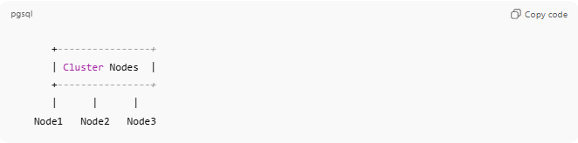
+----------------+
| Cluster Nodes |
+----------------+
| | |
Node1 Node2 Node3
- Nodes may share workload or provide redundancy
- No special configuration for high-performance parallel computing

How Normal Clusters Work
# Source: Chatgpt (GPT-5-Mini) at [1/16/2026]
- Tasks or requests are distributed among cluster nodes
- Nodes process their tasks independently or collaboratively
- If one node fails, others may take over (basic fault tolerance)
- Users see the cluster as a single system

Key Characteristics
# Source: Chatgpt (GPT-5-Mini) at [1/16/2026]
- Tightly or loosely coupled nodes
- Provides basic availability and redundancy
- Handles general-purpose workloads
- May use simple load sharing

Applications
# Source: Chatgpt (GPT-5-Mini) at [1/16/2026]
- File or print servers in organizations
- Basic web or application servers for small-medium systems
- General-purpose computing clusters in offices

Advantages
# Source: Chatgpt (GPT-5-Mini) at [1/16/2026]
- Simple to set up
- Provides redundancy for basic fault tolerance
- Can improve system utilization and availability

Disadvantages
# Source: Chatgpt (GPT-5-Mini) at [1/16/2026]
- Not optimized for high performance or extreme scalability
- Limited fault tolerance compared to HA clusters
- May not handle heavy parallel computation efficiently

Simple Analogy
- Normal Cluster: Several employees in a team sharing workload
- HPC Cluster: Employees working together on one big project simultaneously
- HA Cluster: One employee works while another is ready to take over if the first is absent

If you want, I can make a full visual diagram of all cluster types (Normal, HPC, Load-Balancing, HA) in one image, which is perfect for studying or revision.
Do you want me to do that?

